**Product Name:** ESG Compound score

**Version:** V1

**Phase:** I

**Date:** 1-July-2023

**Product Overview**

The Product is to rank companies based on Environmental, Social, Governance factors. The product calculate E, S, G Scores of the Companies using company’s ESG filling XML file from <https://www.nseindia.com/companies-listing/corporate-filings-bussiness-sustainabilitiy-reports>.

**Product Objectives**

Objective is to calculate ESG Compound Score of the Company. A csv containing

|  |  |  |  |  |  |  |
| --- | --- | --- | --- | --- | --- | --- |
| **CIN** | **COMPANY_NAME** | **E_SCORE** | **S_SCORE** | **G_SCORE** | ESG_classification | compound_score |

Is the output of the product.

**Product Features**

Download company’s ESG filling XML file from <https://www.nseindia.com/companies-listing/corporate-filings-bussiness-sustainabilitiy-reports>.

From all (169) files 435 unique questions are identified and classified into 9 principles. Those principles and questions are mapped into ESG category (Environment, Social, Governance)and are stored in esg_class.csv file. This esg_class.csv file is used to map esg_principle and esg_category to unique questions in each filling. Now all files of individual company has following columns:

|  |  |  |  |  |  |  |  |
| --- | --- | --- | --- | --- | --- | --- | --- |
| **Element Name** | **Period** | **Unit** | **Decimals** | **Fact Value** | **Score** | **Principles** | **esg_category** |

Another script will run over 169 files and extracts following from each file:

|  |  |  |  |  |
| --- | --- | --- | --- | --- |
| **CIN** | **COMPANY_NAME** | **E_SCORE** | **S_SCORE** | **G_SCORE** |

From all the files we have gathered unique questions and classified them under 9 principles.

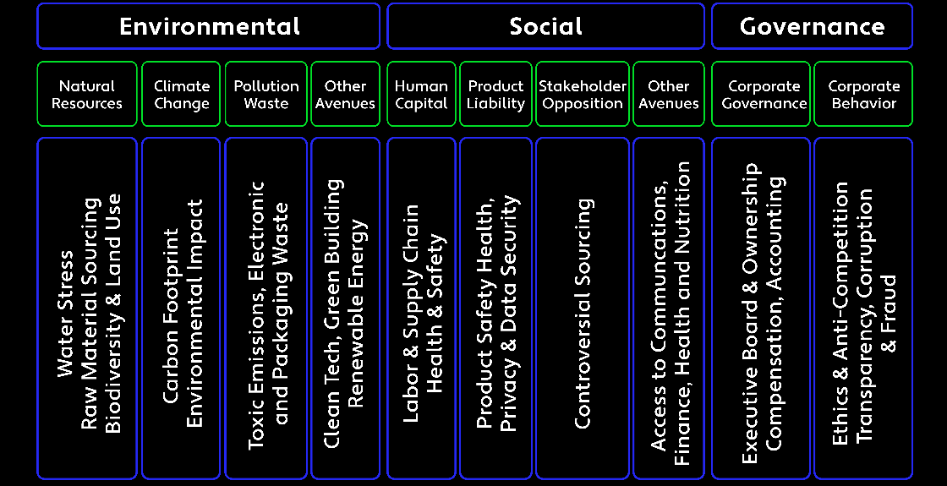

As shown in the DataFrame:

|  | **Element Name** | **Principles** | **esg_category** |
| --- | --- | --- | --- |
| **190** | DoesTheEntityProvideTransitionAssistanceProgra... | Principle 3 | Social |
| **191** | PercentageOfHealthAndSafetyPracticesOfValueCha... | Principle 4 | Social |
| **192** | PercentageOfWorkingConditionsOfValueChainPartn... | Principle 4 | Social |
| **193** | DetailsOfAnyCorrectiveActionTakenOrUnderwayToA... | Principle 4 | Social |
| **194** | DescribeTheProcessesForIdentifyingKeyStakehold... | Principle 4 | Social |
| **...** | ... | ... | ... |
| **509** | RemarksOnApprovalByAuditCommittee | Principle 9 | Governance |
| **510** | AmountOfRelatedPartyTransactionDuringTheReport... | Principle 9 | Governance |
| **511** | AmountOfRelatedPartyTransaction | Principle 9 | Governance |

Then we created a Dictionary containing unique questions as keys and their corresponding value contains principle and ESG category. This dictionary will be used to categorize questions in every file.

Here is snapshot of the dictionary:

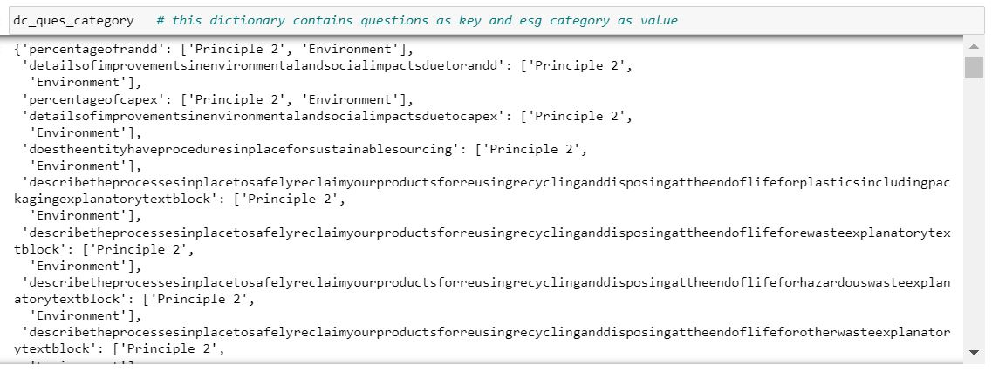

Using this dictionary we will add principle and esg_category column and label all the questions in all the xbrl files.

Once all the files are labeled and categorized into E,S,G, then we will calculate Score.

From each file we need to extract following information:



**This function calculates E,S,G SCORE as follows:**

* Counts all the question in particular category (total).
* Counts all the question where there is a fact value present(sum_of_1). (sanjay’s logic)
* Score = sum_of_1/total

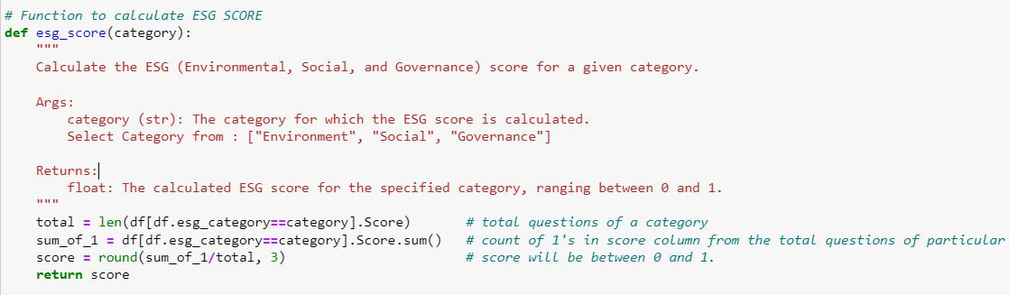

The final dataframe after calculation of score:

|  | **CIN** | **COMPANY_NAME** | **E_SCORE** | **S_SCORE** | **G_SCORE** |
| --- | --- | --- | --- | --- | --- |
| **0** | L31300KA1987PLC013543 | 3M INDIA LIMITED | 0.215 | 0.133 | 0.520 |
| **1** | L65922RJ2011PLC034297 | Aavas Financiers Limited | 0.170 | 0.317 | 0.253 |
| **2** | L32202KA1949PLC032923 | ABB INDIA LIMITED | 0.581 | 0.484 | 0.591 |
| **3** | L51100GJ1993PLC019067 | Adani Enterprises Limited (“AEL or the Company”) | 0.583 | 0.493 | 0.613 |
| **4** | L40106GJ2015PLC082007 | Adani Green Energy Limited | 0.287 | 0.272 | 0.530 |
| **...** | ... | ... | ... | ... | ... |
| **164** | L29150TG1930PLC000576 | VST INDUSTRIES LIMITED | 0.443 | 0.383 | 0.436 |
| **165** | L27100GJ1995PLC025609 | WELSPUN CORP LIMITED | 0.386 | 0.415 | 0.566 |
| **166** | L17110GJ1985PLC033271 | Welspun India Limited | 0.413 | 0.393 | 0.451 |
| **167** | L32102KA1945PLC020800 | Wipro Limited | 0.385 | 0.341 | 0.747 |
| **168** | L34103TN2004PLC054667 | ZF COMMERCIAL VEHICLE CONTROL SYSTEMS INDIA LI... | 0.434 | 0.472 | 0.577 |

Factacy classification is mapped to ESG_classification (industry classification). Through a dictionary: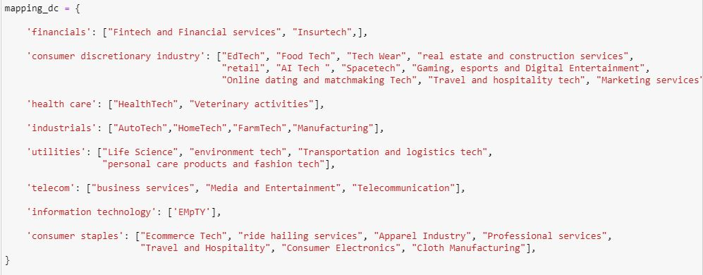

This function will use above dictionary to map factacy to esg classification



**COMPOUND SCORE**

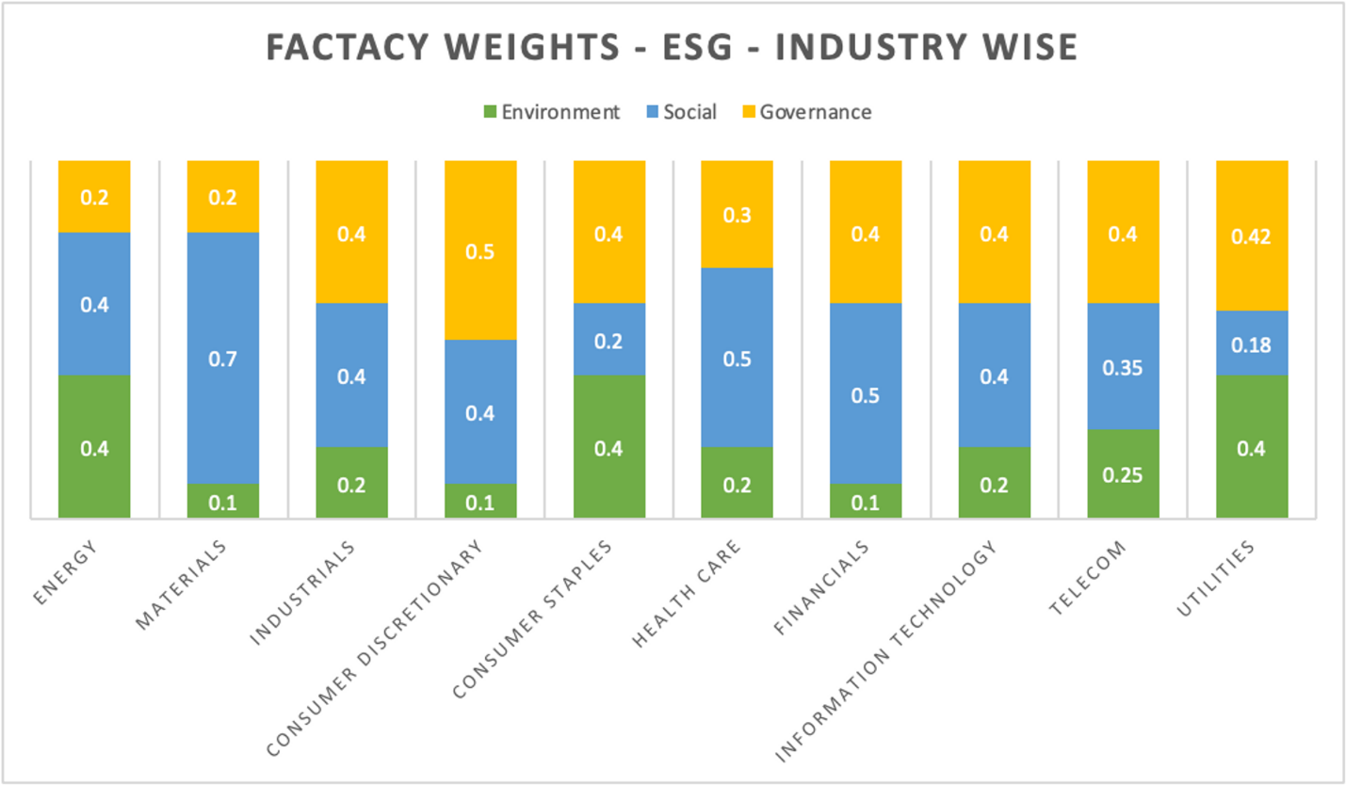

This code snippet is calculating Compound Score:

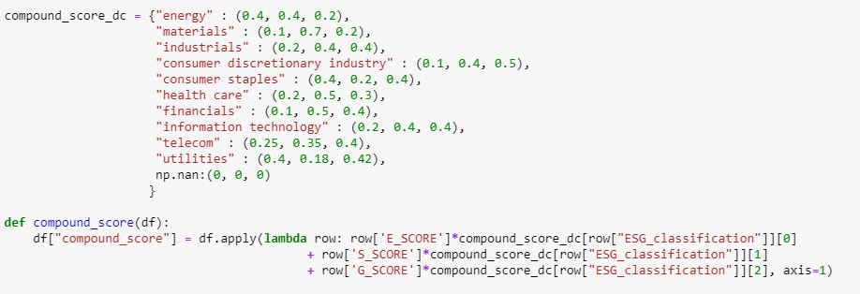

**Technical Support Contact Information**

[imran@factacy.ai](mailto:imran@factacy.ai)